The Students of
Philadelphia Studio Ballet
present

SHOWCASE 2021:
A Dancer’s Tale
(in spite of everything)
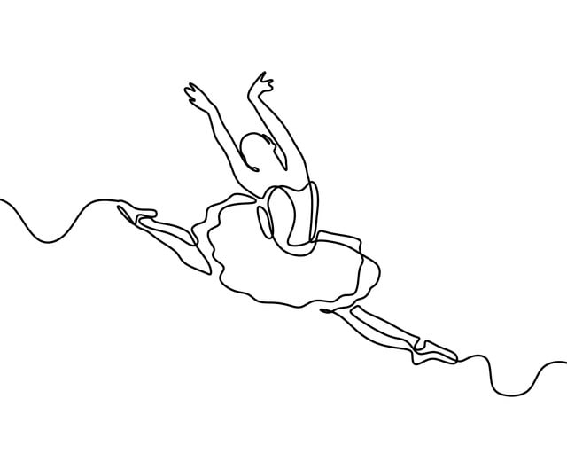

WEDNESDAY, JUNE 9th
6:00pm
Levering Mill Tribute House
Bala Cynwyd, PA

info@philadelphiastudioballet.com
philadelphiastudioballet.com

ORDER OF SHOW

- Nursery
- Time & Space
- Mermaids
- Flying
- Flapper Fish
- Tiger Lily & Drummers
- Lost Boys
- Wendy Bird
- Fairies
- Croc Interlude #1
- Pirate Dance

<Intermission>

- Dragonflies
- Hook & Smee Tango
- Croc Interlude #2
- Butterflies
- Tiger Lily
- Warriors & Lost Boys
- Peace Dance
- Poison Kidnapping
- Battle
- Flying Home

CAST
The Darling Family
Wendy Samantha Manogue
John Reese Rehl
Michael Claire Cusick
Nana Sydney Moritz
Mr. Darling Preston Moritz
Mrs. Darling Debbie Piasecki
Peter Pan Avery Rehl
Shadow Jacqui Stuart
Tink Fiona Peterson
Hook Paige Mullen
Smee Caroline McNally
Tiger Lily Anna Rose Hunt-Isaak
Time/Space
Hannah Downing
Anna Rose Hunt-Isaak
Eliza Liebo
Eden McCloskey
Jacqui Stuart
Gabryelle Tepper-Waterman
Mermaid Queen Jacqui Stuart
Mermaids
Madeline Corcoran
Faith Coyle
Libby Coyle
Caroline McDonnell
Dylan Spivack
Elsa Stuart

Gabryelle Tepper-Waterman
Grace Vauclain
Flapper Fish Eden McCloskey
Flapettes
Sasha Grollman
Caroline McDonnell
Elsa Stuart
Gabryelle Tepper-Waterman
Baby Fish
Kamila Crespo
Lucy Davis
Sadie Glassner
Sydney Moritz
Lydia Piasecki
Sutton Rehl
Drummers
Teagan Panzer
Vivian Piasecki
Rufio Libby Coyle
Lost Boys
Remi Carabasi
Madeline Corcoran
Faith Coyle
Eden McCloskey
Eleanor Mulligan
Dylan Spivack
Grace Vauclain

Fairy Queen Eliza Liebo
Fairies
Remi Carabasi
Berkley Daggett
Eleanor Mulligan
Teagan Panzer
Vivian Piasecki
Katarina Puskovic
Carly Ytterberg
Crocodile Remi Carabasi
Pirates
Madeline Corcoran
Libby Coyle
Faith Coyle
Eden McCloskey
Reese Rehl
Dylan Spivack
Grace Vauclain
Lead Dragonfly Gabryelle Tepper-Waterman
Dragonflies
Remi Carabasi
Berkley Daggett
Sydney Moritz
Eleanor Mulligan
Teagan Panzer
Vivian Piasecki
Katarina Puskovic
Carly Ytterberg

Lead Butterflies
Sasha Grollman
Caroline McDonnell
Elsa Stuart
Butterflies
Kamila Crespo
Lucy Davis
Sadie Glassner
Sydney Moritz
Lydia Piasecki
Sutton Rehl
Warriors
Hannah Downing
Sasha Grollman
Eliza Liebo
Caroline McDonnell
Elsa Stuart
Jacqui Stuart
Gabryelle Tepper-Waterman

Artistic Director
Suzanne Slenn

Faculty
Tyger B., Jim Bunting, Felicia Cruz, Sydney Donovan,
Nora Gibson, Meredith Reffner-Callender

Wardrobe Mistress
Melissa Hunt
Lynn VanDerryt

Special thanks to all the parents!

REGISTER FOR OUR SUMMER CAMPS!
www.philadelphiastudioballet.com/camp

